**Output & Cost**

Marginal Product (MP) = $$\frac{Change in Total \operatorname{Pr}{o}duct }{Change in Labour}$$

Average Product (AP) = $$\frac{Total \operatorname{Pr}{o}duct}{Total Labour}$$

Total Cost (TC) = Fixed Cost (FC) + Variable Cost (VC)

Average Total Cost (ATC)= $$\frac{Total Cost}{Total \operatorname{Pr}{o}duct}$$

Marginal Cost (MC)= $$\frac{Change in Total Cost}{Change in Total \operatorname{Pr}{o}duct}$$

Average Fixed Cost (AFC)= $$\frac{Total Fixed Cost}{Total \operatorname{Pr}{o}duct}$$

Average Variable Cost (AVC)= $$\frac{Total Variable Cost}{Total \operatorname{Pr}{o}duct}$$

ATC=AFC + AVC

1. Table 1 shows how the quantity of cookies produced per hour at Caroline’s factory depends on the number of workers.

Calculate the missing data.

|  |  |  |  |  |  |  |  |  |  |
| --- | --- | --- | --- | --- | --- | --- | --- | --- | --- |
| Labour | Output | Marginal Product (MP) | Total Cost (TC) | Average Total Cost (ATC) | Marginal Cost (MC) | Total Fixed Cost (TFC) | Average Fixed Cost (AFC) | Total Variable Cost (TVC) | Average Variable Cost (AVC) |
| 0 | 0 | - | 30 | - | - | 30 | - | 0 | - |
| 1 | 50 | 50 | 40 | 0.8 | 0.2 | 30 | 0.6 | 10 | 0.2 |
| 2 | 90 | 40 | 50 | 0.55 | 0.25 | 30 | 0.33 | 20 | 0.22 |
| 3 | 120 | 30 | 60 | 0.5 | 0.33 | 30 | 0.25 | 30 | 0.25 |
| 4 | 140 | 20 | 70 | 0.5 | 0.5 | 30 | 0.214 | 40 | 0.285 |
| 5 | 150 | 10 | 80 | 0.53 | 1 | 30 | 0.2 | 50 | 0.33 |
| 6 | 155 | 5 | 90 | 0.58 | 2 | 30 | 0.19 | 60 | 0.38 |

1. Bill’s bakery has a fire and Bill loses some of his cost data. The bits of paper that he recovers after the fire provide the data in the following table (all the cost numbers are euros).

|  |  |  |  |  |
| --- | --- | --- | --- | --- |
| **TP** | **AFC** | **AVC** | **ATC** | **MC** |
| 10 | 120 | 100 | 220 | 0 |
| 20 | A | B | 150 | 80 |
| 30 | 40 | 90 | 130 | 90 |
| 40 | 30 | C | D | 130 |
| 50 | 24 | 108 | 132 | E |

Calculate the missing cost data identified as A, B, C, D and E from the table provided above.

To FIND A which is AFC we need to find TFC from any of the rows:

TFC at 10 units of TP = 120 X 10 = 1200 (Since AFC=TFC/TP AND TFC IS SAME FOR ALL THE OUTPUTS)

So, A is AFC at 20 Units of TP = 1200 / 20 = 60

B is AVC at 20 Units of TP = ATC-AFC= 150 – 60 = 90

To find C, find D first:

D is ATC at 40 Units of TP, ATC=TOTAL COST/ TOTAL OUTPUT

To find TOTAL COST, check MC at 40 Units,

MC40 = $$\frac{Total Cost at 40 Units − Total Cost at 30 Units}{40−30}$$

130= (Total cost at 40 units-(130 x 30))/10

TC AT 40 Units = 5200

ATC= 5200/40= 130 = D

AVC AT 40 Units = 130 – 30 = 100 = C

To find E which is MC at 50 Units of TP= $$\frac{6600−5200}{50−40}$$ = 140

**Perfect Competition**

Total Revenue (TR) = Price X Quantity

Average Revenue (AR) = $$\frac{Total Revenue}{Total \operatorname{Pr}{o}duct}$$

Marginal Revenue (MR) = $$\frac{Change in Total Revenue}{Change in Total \operatorname{Pr}{o}duct}$$

Profit= TR - TC

PC firms always operate at the Profit Maximizing Quantity which is found at the point where MR=MC.

1. The table below shows the cost of production for upholstery fabric produced by Thomas Textiles. The fabric is sold in a perfectly competitive market.

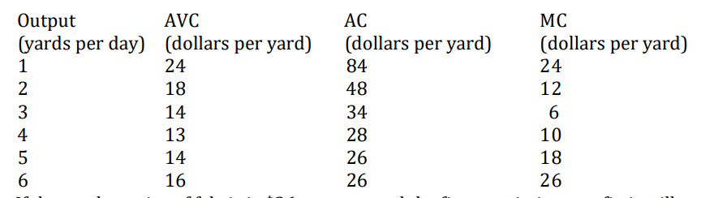

If the market price of fabric is $26 per year and the firm maximizes profit, how much output will it produce?

MARKET Price=26

At Profit Maximization, firm operates at the point where p=mc so when MC=26, OUTPUT= 6 Units

1. Consider total cost and total revenue given in the following table:

|  |  |  |  |  |  |
| --- | --- | --- | --- | --- | --- |
| Quantity | 0 | 1 | 2 | 3 | 4 |
| Total Cost | $8 | 9 | 10 | 11 | 13 |
| Total Revenue | $0 | 8 | 16 | 24 | 32 |

1. Calculate profit for each quantity. How much should the firm produce to maximize profit?

|  |  |  |  |  |  |
| --- | --- | --- | --- | --- | --- |
| Quantity | 0 | 1 | 2 | 3 | 4 |
| Total Cost | $8 | 9 | 10 | 11 | 13 |
| Total Revenue | $0 | 8 | 16 | 24 | 32 |
| Profit = TR-TC | -8 | -1 | 6 | 13 | 19 |

The company should produce 4 units for maximum profit.

1. Calculate marginal revenue and marginal cost for each quantity.

|  |  |  |  |  |  |
| --- | --- | --- | --- | --- | --- |
| Quantity | 0 | 1 | 2 | 3 | 4 |
| Total Cost | $8 | 9 | 10 | 11 | 13 |
| Marginal Cost | - | 1 | 1 | 1 | 2 |
| Total Revenue | $0 | 8 | 16 | 24 | 32 |
| Marginal Revenue | - | 8 | 8 | 8 | 8 |

1. Refer to the graph provided below:

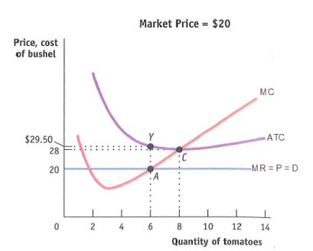

1. Assuming it is appropriate for the firm to produce in the short run, what is the firm’s profit-maximizing level of output

Profit maximizing level is at MC=MR which is 6 UNITS of output will be produced in the short run.

1. Calculate the firm’s total revenue.

TR = price of tomatoes x quantity produced in the short run = 20 * 6= 120

Or, you can directly calculate the area of rectangle on the graph.

1. Calculate the firm’s total cost.

Total Cost= Area of rectangle of TC= 29.5 X 6 =177

1. Calculate the firm’s profit or loss. Profit =120-177= -57 (Loss)
2. If AVC were $22 at the profit-maximizing level of output, would the firm produce in the short run? Explain why or why not. No, because p< avc so shut down temporarily.